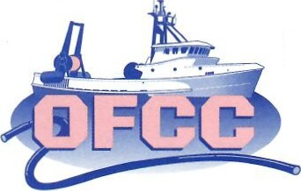

OREGON FISHERMEN'S CABLE COMMITTEE
Established as Oregon Fishermen's Undersea Cable Committee July 9, 1998

2021 Marine Drive, Suite 102
Astoria, Oregon 97103
Phone (503) 325-2285
Fax (503) 325-7012
www.ofcc.com

Hydrographic Services Review Panel
Public Comment
Aug. 30, 2018

Members of the HSRP,
I would like to express our interest in the appropriate use of Virtual AIS beacons for private aids to navigation. A few examples of new and emerging ocean uses clearly show the value and need for private aids to be able to take advantage of using virtual AIS.

Imagine a new offshore wind farm where mariners could see a virtual AIS signal for each tower. Imagine ocean fish farming pens which may not have much of an radar reflection, but which could be easily seen to most mariners if a private virtual AIS signal were able to be transmitted showing the net pen location. In our case, we are interested in having a virtual AIS marker for a subsurface science platform on the high seas. This platform is at risk since there is no surface expression, but has a buoy that comes close to the surface multiple times each day as part of the scientific sampling conducted by the National Science Foundation through the Ocean Observatories Initiative.

Please encourage the US Coast Guard to develop a process for application and approval of private ATONS using virtual AIS transceivers.
Best regards,

/s/

Scott McMullen, Chairman

