Marine and Geospatial Data Infrastructure Is Vital to the U.S. Economy DRAFT v28MAR2018

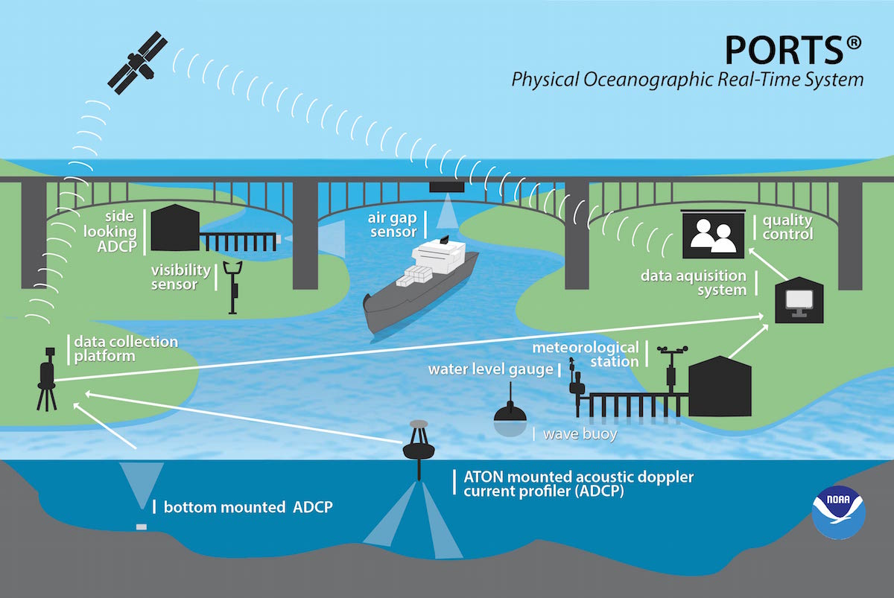
Infrastructure is the fundamental facilities and systems serving a country, including (1) physical infrastructure and (2) information infrastructure necessary for its economy to function. Physical infrastructure primarily includes roads, bridges, railroads, ports and navigation channels, airfields and key facilities. Information infrastructure includes spatial information relevant to specific locations that is needed for decision-making. Unlike land-based infrastructure, physical marine infrastructure cannot fully benefit maritime commerce without the Marine and Geospatial Data Infrastructure (MGDI), including: accurate and up-to-date navigation charts; accurate real-time 3-D positioning relevant to ship channels, predicted under-keel clearance and overhead obstructions, and key services such as Physical Oceanographic Real Time System (PORTS®) and the pilot Precision Navigation project in Los Angeles/Long Beach (LA/LB), both of which provide real-time quality-controlled oceanographic and meteorological observations supporting vessel safety and efficiency decisions. The extent of NOAA’s National Ocean Service (NOS) contributions to the MGDI are not well-known and are not widely recognized outside the maritime community as being vital to the U.S. economy, to public safety, and to preservation of life and property.
PORTS® installations are a part of the MGDI and provide multiple real-time data streams that increase safety of navigation and reduce the number of collisions and groundings.

The President’s Infrastructure Plan should expand the traditional infrastructure definition of physical infrastructure to include the equally critical spatial data infrastructure that actively invests in technology, data, procedures and skilled people to provide the geospatial knowledge required to understand, protect and promote the national and global interests of the United States. Specifically, the President’s proposal for improving the United States’ infrastructure in 2018 should include the MGDI, which controls the safe and efficient operation of U.S. ports and harbors that drive a major portion of the U.S. economy. NOAA Administration should highlight and emphasize the value of NOS’ MGDI services to the Department of Commerce, the Office of Management and Budget, and to Congress, and should prioritize funding at levels that will accelerate MGDI improvement.

BACKGROUND
Data products obtained from NOAA assets—ships, watercraft, aircraft, sensors, and systems—are the essential building blocks of National Ocean Service’s (NOS) contributions to the MGDI. Examples of these products include nautical charts, tidal observations, storm surge estimates, geodetic measurements, and reports. With the active support of the MGDI, data products from physical surveys, sensors, and systems may be acquired once and used many times, often to great economic benefit.
NOAA’s NOS provides services that support the MGDI, including both government-funded projects and public-private partnerships (PPPs) that are national in scope and impact. PORTS® illustrates a highly successful NOS PPP at 31 locations that handle over 80 percent of cargo weight and tonnage transiting U.S. seaports. A 2016 study¹ showed that collisions were reduced by 62.6% in seven ports after PORTS® was installed. A 2013 study² estimated over $300M annual economic benefit if PORTS® were fully implemented at major seaports around the country. The pilot Precision Navigation project in LA/LB ingests PORTS®-derived real-time information such as depth, water level, swell, sea conditions, and clearance with ship-specific information such as motion characteristics, draft, and beam and integrates these data into a model that aids ship captains, pilots, and port personnel in decision making. This PPP allows ever-larger ships with draft restrictions to transit LA/LB harbor more safely. In LA/LB for every foot of increased draft that can be used, tanker ships can load 40,000 more barrels of crude oil, which equates to $2 million/foot.³
Nautical charts are NOS’ most well-known data product. Analyzing data from existing charts stored in the MGDI with post-crisis surveys helps minimize economic losses after natural disasters such as 2017 Hurricanes Harvey, Irma, and Maria. By comparing what was known to be safe with new survey data, NOS can provide timely information to US Coast Guard Port Captains on when they can re-open their facilities. Time is of the essence with these surveys: closing a major port, such as LA/LB, for a single day can cost the U.S. economy $65-$150M.⁴ By contrast, the 2017 House Budget Allocation to all NOS hydrographic survey contracts was $25M—less than half of the low-end economic cost of a major port being closed for one day.⁵
Less well known, but equally important, are NOS’ efforts to improve the quality of terrestrial and marine positioning. Accurate, up-to-date horizontal and vertical reference frames, or datums, are critical to designing high-quality physical infrastructure projects and floodway management plans. Datums are periodically updated to account for natural earth movement and to take advantage of new technology. The National Geodetic Survey (NGS), an office within NOS, has a federal mandate to define, maintain, and provide access to the National Spatial Reference System (NSRS), the coordinate system which provides accurate positioning, including heights, to all federal non-military mapping activities in the USA and its territories. NGS is currently collecting a continuous gravity dataset (GRAV-D) that will be used to modernize the NSRS. The MGDI provides the technology and skilled personnel for analysis and a way to transmit the new reference frames to the public upon its scheduled release in 2022. A January 2009 study⁶ showed that the preliminary economic benefit of completing GRAV-D is estimated to be $4.8 billion over 15 years, including $2.2 billion in avoidance costs from improved floodplain management, which is critical for planning for the effects of flooding and sea level rise.
NOAA and NGS are key partners in the 3D Nation Elevation Requirements and Benefits Study to determine the most cost-effective way to map the U.S. from the tops of the mountains to the depths of the ocean, to include inland bathymetry, near-shore and offshore bathymetry. The 3D Nation Study is a follow-on to USGS’ National Enhanced Elevation Assessment of 2012 that documented a minimum of 5:1 Return on Investment from enhanced topographic data for 602 Mission Critical Activities (MCAs). The 3D Nation Study will also address diverse bathymetric data requirements and benefits for MCAs from NOAA’s geospatial data.
Innovative uses of NOS data stored in the MGDI can provide further economic, public safety, and quality of life benefits to the United States. An exciting possibility is expanding the scope of the MGDI to include general bathymetric data within the United States’ Extended Continental Shelf, which could benefit the nation by supporting and accelerating the siting and permitting of offshore energy projects like wind farms and oil and gas developments, and allowing industries to leverage the enhanced information to improve their efficiency and have direct economic benefits.
RECOMMENDATIONS
The Hydrographic Services Review Panel recommends that NOAA Administration should:
- Conduct briefings to the Department of Commerce and Office of Management and Budget to emphasize the value of NOS’ MGDI services to the economy. Focus on education and outreach to Congressional oversight committees to prioritize funding at levels that will accelerate marine and maritime infrastructure improvement.
- Advertise NOS MGDI products, services, and capabilities as an economic driver and theme for NOS and NOAA in internal and external briefings, on websites and messages from the NOS Assistant Administrator, NOAA Administrator, etc.
- Work with other federal agencies to document the costs and benefits of the MGDI to the economy.

References:
¹ Wolfe, K. Eric and MacFarland, David, 2016. “A Valuation Analysis of the Physical Oceanographic Real Time System (PORTS®),” Journal of Ocean and Coastal Economics, Vol. 3, Issue 1, Article 12.
² https://tidesandcurrents.noaa.gov/publications/ASSESSMENT_OF_THE_VALUE_OF_PORTS_TO_THE_US_ECONOMY.pdf
³ https://aamboceanservice.blob.core.windows.net/oceanservice-prod/economy/precision-navigation/Long-Beach-precisionnav.pdf
⁴ https://www.cbo.gov/sites/default/files/109th-congress-2005-2006/reports/03-29-container_shipments.pdf.
⁵ https://appropriations.house.gov/uploadedfiles/hrpt-114-hr-fy2017-cis.pdf.
⁶ https://www.ngs.noaa.gov/GRAV-D/pubs/GRAV-D_Contribution_to_NOAA_Science.pdf.

