The NOAA Hydrographic Survey Fleet: A Critical National Asset

The single most pressing need for recapitalization of the NOAA fleet is replacement of two of the oldest vessels, the hydrographic survey ships Rainier and Fairweather. The Hydrographic Services Review Panel (HSRP) recommends that NOAA prioritize hydrographic survey fleet needs and accelerate plans to acquire and modify or construct an Arctic-capable hydrographic survey vessel that carries multiple launches.

ISSUES AND STATUS

Dedicated ships carrying multiple survey launches are one of the most efficient and cost-effective ways to conduct hydrographic surveys. The NOAA ships Rainier and Fairweather were built in 1968 with an original design life of 30 years and each carries five survey launches. Although well past their original design life, both vessels still conduct annual surveys in challenging Alaskan and Arctic waters. Retirement of one or both of these vessels before a replacement is available would severely limit NOAA’s ability to perform Arctic surveys and decrease the long-standing survey backlog.

The NOAA hydrographic fleet provides hydrographic information that is essential for safe navigation and keeping our ports open and commerce flowing, as mandated by numerous federal statutes^{1,2}. This information is not only the foundation for up-to-date nautical charts, but also plays a key role in storm readiness, disaster recovery, coastal resilience and on-time delivery of goods and services to the nation. Whether by conducting critical hydrographic surveys or by providing emergency surveys after storms or tsunamis, the ships and launches are an important part of our national infrastructure.

The ships and launches of NOAA’s hydrographic fleet also play vital roles in research and maintenance of expertise.
- NOAA uses private/government partnerships to develop innovative survey equipment and techniques, which are evaluated and placed in service on these vessels.
- Almost 50 percent of NOAA junior officers are trained in hydrography and sonar technologies aboard the hydrographic ships and launches, in addition to qualifying as officers of the deck.
- NOAA contracts with commercial vendors for approximately half of its hydrographic surveys. Although contracting for a portion of surveys is an important element of Coast Survey’s portfolio, NOAA must also maintain in-house survey capability and expertise to effectively manage hydrographic surveys and ensure navigation safety.

In offshore or remote areas such as the Arctic, Alaska, and the Pacific, it is impossible to perform critical surveys without dedicated ships. Unscheduled maintenance days for NOAA ships Rainier and Fairweather greatly affect the amount of surveying that can be accomplished.

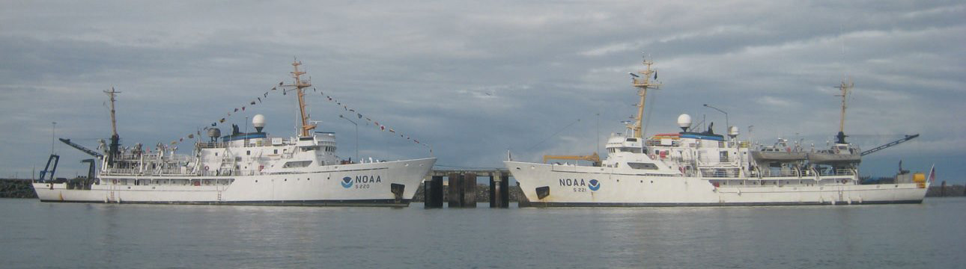
NOAA ships Rainier and Fairweather were built in 1968 with an original design life of 30 years
CHALLENGES

Important elements of the NOAA hydrographic survey fleet are operating past their operational life span. The only two NOAA ships assigned to Alaska are now 50 years old, well past their service life of 30 years. Due to the age and design of these ships, there are significant management challenges with respect to maintenance, environmental compliance, staffing, habitability, and ability to operate in the severe Arctic environment. These problems have led to steadily declining productivity and, in some cases, loss of an entire year’s survey time.

Without reliable survey ships, the brief three-month survey window in Alaska makes accomplishing NOAA’s critical survey mandates in the Arctic and other remote areas difficult, if not impossible at times. The hydrographic survey backlog is approximately 10,000 square nautical miles (snm). (The current goal for Arctic surveys is 500 snm/ year). NOAA needs both its own ships and commercial capabilities to reduce the current backlog and keep up with future survey needs.

The HSRP has repeatedly advised the NOAA administrator of the need to prioritize hydrographic surveys and the hydrographic fleet. In 2016 and 2017 $155M has been appropriated for replacement of NOAA vessels. The first vessel to be constructed is planned to be a multi-purpose Pacific oceanographic/fisheries research vessel, partly because existing plans for the AGOR vessels Neil Armstrong and Sally Ride can be used as a starting point for the design. Even with an existing plan, completion of this vessel is not expected until 2022. Following the current NOAA plans for a new design for hydrographic vessels, it is likely that a new hydrographic vessel would not be completed for perhaps 10 years. Is it realistic to expect that the aging Rainier or Fairweather will be able to operate for another 10 years? If one or both of these vessels go out of service before a new vessel is available, the survey backlog will only increase.

There are a number of commercial, academic, and government vessels that might be available for acquisition and conversion to a hydrographic survey vessel that can carry multiple launches. In late 2017 NOS released a request for information about the availability of academic, government, or commercial vessels for lease or purchase. Acquisition and modification of an existing vessel would almost certainly be less costly than designing and building a completely new type of vessel and could be accomplished in a much shorter time. NOAA should consider all options in order to replace at least one of the Arctic survey vessels as expeditiously as possible.

The HSRP recommends that NOAA should:
- Prioritize hydrographic survey fleet needs and accelerate plans to acquire and modify or construct an Arctic-capable hydrographic survey vessel that carries multiple launches.
- Continue to request annual funding for fleet replacement and allocate a portion of annual funds to replacement of the hydrographic fleet.
- Continue to coordinate with other federal agencies, academic organizations, state and local interests, and private and commercial entities to develop a whole government approach to the problem of aging oceanographic fleets.

¹Coast and Geodetic Survey Act of 1947; ²Hydrographic Service Improvement Acts of 1998/2002/2008; Ocean and Coastal Mapping Integration Act (2009)

