MAKING PRECISION NAVIGATION THE NEW NORM IN APPROACHES AND PORTS

ISSUES
As the world economy grows and maritime trade increases, our nation’s commercial ports, vessel operators, and maritime pilots face increasing pressure to navigate safely within increasingly constrained spaces. Maneuvering more and significantly larger ships in narrow channels and harbors requires continued development of innovative technology and tools to support ships’ captains and pilots, especially when improving physical infrastructure comes at a high economic and environmental cost. NOAA, through its precision navigation concept demonstration in Long Beach, has demonstrated that significant safety and economic gains can be achieved through integrating enhanced navigational and meteorological information and forecasts into intuitive products and tools for mariners. Given the success of the concept demonstration and the demand for program expansion nationwide from commercial and government operators alike, NOAA, specifically OCS, NGS, and COOPS, should develop an official national program for precision navigation that presents a formal, unified approach to collecting, collating, and sharing observational and geospatial data with maritime operators, thereby ensuring safe and efficient operations in constrained port and harbor environments.

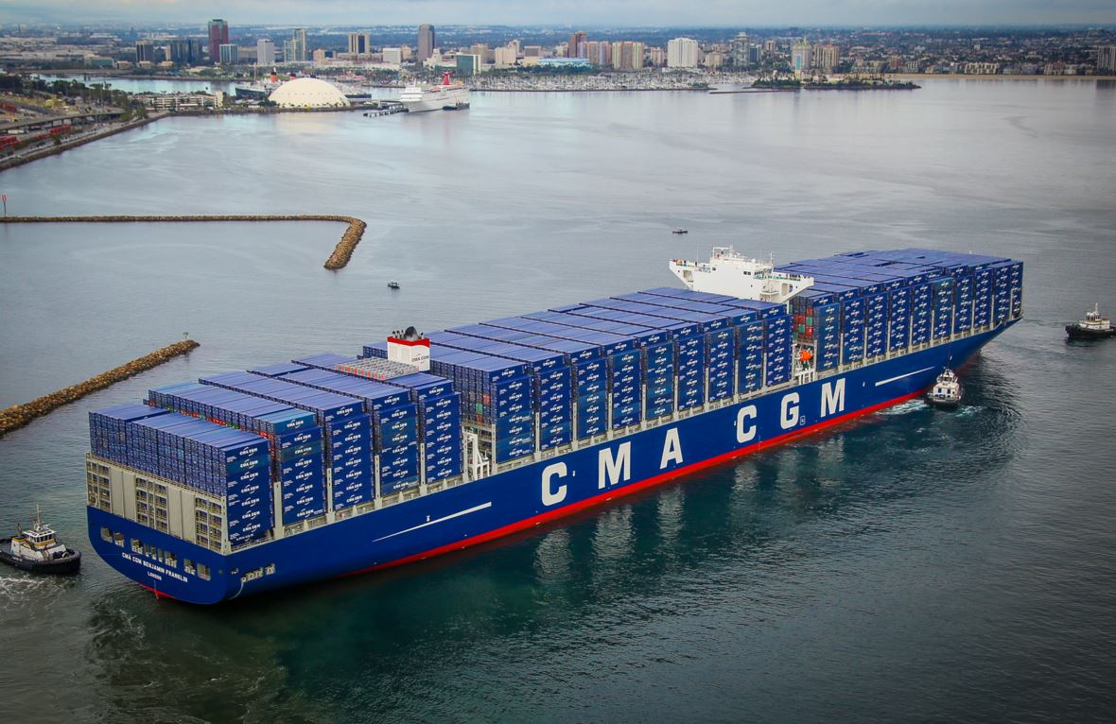
Precision navigation has become synonymous with the process of gathering and integrating many types of oceanographic and atmospheric data to create more accurate navigational products and tools that support the mariner’s operational decision-making process and the determination of navigational tolerances. NOAA has worked to define this process and its associated products with the maritime industry with its pilot concept demonstration program and recognizes the benefits of and demand for a unified operational forecast model. Establishing and funding precision navigation as an official nationwide program for the next generation of maritime navigation would allow NOAA meet growing demand, and lead in formally establishing precision navigation as the new normal for safely and efficiently navigating ports and harbors.
Megaship CMA CGM Benjamin Franklin entering the Port of Long Beach. Image Credit: Port of Long Beach

THE CASE FOR PRECISION NAVIGATION
Due to uncertainty inherent in current navigational products, operating tolerances are often greater than they could be out of an abundance of caution. With the introduction of more accurate information and products, these operating limitations can be tailored to accommodate smaller margins of error while still ensuring that navigating maritime approaches and constrained environments is safe. These decreased tolerances would allow ships to maximize their load, and the economic impact of increasing inbound and outbound cargoes could be exponential. For example, according to a NOAA publication an inbound vessel carrying an extra 40,000 barrels of crude, which equates to an additional foot of draft, brings with it an additional $2M in trade value. This could substantially reduce the need for offshore lightering, reducing costs by approximately $500K per evolution.

To achieve these gains mariners must know their vessel’s current and future position in three dimensions within a inches of the seabed. It will require a shift from “normal" navigation (with safety percentages added) in ports to the precision navigation paradigm, which requires an understanding of the data provided by new technology and of model uncertainty in limiting risk during navigation. However, vessel loading and passage planning tools based on total propagated uncertainty measurements and probability analysis will likely allow ports to increase their profits and improve safety while optimizing physical infrastructure (e.g. dredging) investments.

A sound strategy and investment are needed to support this effort. Getting more accurate information and products into the hands of mariners will require the collation and integration of disparate data sources into a robust common digital infrastructure, or database, that adheres to international standards. Additionally, an informative and intuitive display for the mariner on the bridge is required to ensure that these products are available, useful, and consistently employed during the operational decision-making process.

CHALLENGES
Expanding the precision navigation program will require NOAA to:
- work with industry to coordinate a careful evaluation to identify and overcome current issues such as meter/feet/fathom conversion errors, datum conversions, scaling inaccuracies, slow delivery of port Electronic Navigation Chart (ENC) updates, and the transition to new horizontal and vertical datums in 2022;
- identify the base level of environmental parameters needed for major ports to support precision navigation and the optimal technology for dissemination;
- clearly quantify the limits and risks associated in precision navigation in constrained channels and ports;
- educate and encourage industry to use the data and associated products, driving towards a more safe and efficient maritime industry; more specifically quantifying the benefits of precision navigation in terms of trade volumes (overcoming the potential proprietary concerns of industry); and
- obtain continued and stable funding sources to support the development of a formal precision navigation program to support safe and efficient navigation in U.S. ports

RECOMMENDATIONS
The Hydrographic Services Review Panel recommends that NOAA:
- Review the Long Beach precision navigation demonstration project and similar international operations with industry to develop lessons learned/best practices.
- Develop/formalize a program of record for precision navigation, with an aim towards developing: 1) the unified data infrastructure needed to support precision navigation products and services; 2) a full prototype in Long Beach and ultimately an expansion of the program to other U.S. ports that accounts for different operational characteristics; and 3) a marketing/education strategy for precision navigation data and product users.
- Lead the ongoing coordination with the U.S. Army Corps of Engineers, ports, and contractors to ensure the organization and technology is established for rapid exchange of all data affecting navigation in U.S. ports. (It should be made clear that any dredging or construction project is not complete until the chart is updated.)
- Continue to collaborate with international hydrographic agencies, marine operators, and industry manufacturers of precision navigation and port operation systems to support international navigational standards, data management, and electronic charting and display systems.
- Ensure funding for research, development, and implementation of a nationwide precision of navigation program.

NOAA, “NOAA Port of Long Beach Precision Navigation Project,” https://www.nauticalcharts.noaa.gov/staff/ocs-biweekly/pdf/lalb-precisionnav.pdf, May 2017.

