National Charting Plan
A Strategy to Transform Nautical Charting

Version Date: February 28, 2017

Draft HSRP Comments – June 5, 2017

NB: The order in which comments are presented is intended to correspond to the relevant sections of the National Charting Plan (NCP) draft.

- Document Proofreading/Editing

- Sources of Data Used to Maintain Charts
2.1 New Chart Source Data
2.2 New Editions of Paper Charts

- ENC and RNC Chart Updates and New Editions
3.1 Normalizing ENC Depth Contours
3.2 Metricfication of ENC and Raster Charts
3.3 Reducing Unwarranted Alarms/Isolated Dangers
3.4 Channel Tabulations
3.5 Reported, Existence Doubtful, and Position Approximate Dangers

- Small Craft Charts

- U.S. Army Corps of Engineers Data for Ship Channels

- Vision for the Future of the Nautical Charting
6.1 The End of Raster Nautical Charts
6.2 Prot ECDIS - Port ENC

Document proofreading/editing

- The general layout of the Plan and the infographics for Figure 1 and for Annex A are well done and logical. Suggestions for specific modifications are made in the following sections.

- Define “Raster Format” and “Vector Format” earlier in the document since the terms are discussed in the introduction. Perhaps in a side bar or box. (pg. 6).

- “Data” is used as singular in some cases and used as plural in other cases. This should be standardized as plural.

- “Notice to Mariners” is spelled with capital letters in some instances and spelled with lower case letters in other instances. This should be standardized with capital letters.

- “Comprised” (pp. 6, 12, 27): Used correctly on page 6. “Comprised of” on pp. 12 and 27 is incorrect.

- Pg. 16. Sentence “This includes the results of …, which could be extensive, but have not identified any immediate dangers.” This sentence is awkward because the noun “results” doesn’t really match extensive or identified.

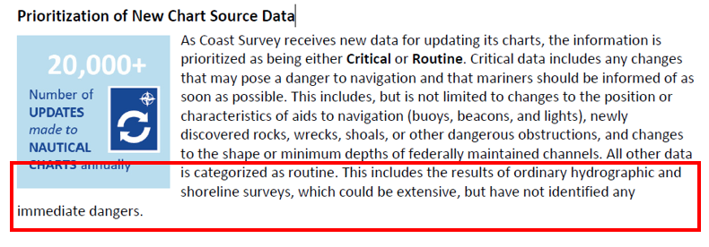

- Pg. 17. Sentence beginning “NOAA produces …” ENC should be plural and no comma between ENCs and “and”.
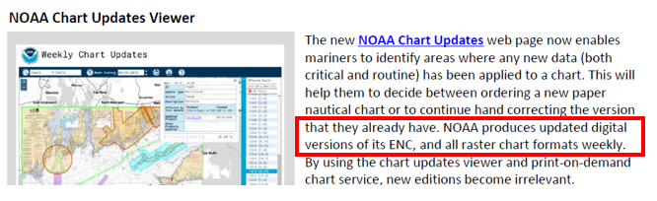

- Pg 21: “Reported, Existence Doubtful, and Position Approximate Dangers” should be its own 3rd-level section, instead of a 4th-level section of “Channel Tabulations, as it is an independent issue separate from channel depths. In addition, the word “rep” in the middle of the page should be capitalized as “Rep” (see below).

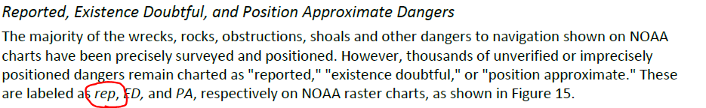

- Title for the Vision for the future of the Nautical Charting – Suggest either removing the “the” or changing “Charting” to “Chart.”

Sources of data used to maintain charts

New Chart Source Data

- The document does not address inclusion of any other bathymetric data sources except that from USACE. It should discuss data sources other than NOAA and USACE that might be used on charts: HSD contractors, US Coast Guard, US Navy, survey companies contracted to Port and Harbor Authorities, etc.

Suggest using the 2007 Portland Combined Survey (H11467, W00177, F00524) as a case study for how to triage, review, and include outside source data.

- Pg 14: Suggest that contractors be added as a source of hydrographic surveys. Change could be “… for hydrographic surveys conducted by Coast Survey’s Hydrographic Survey Division (HSD) and HSD contractors.”

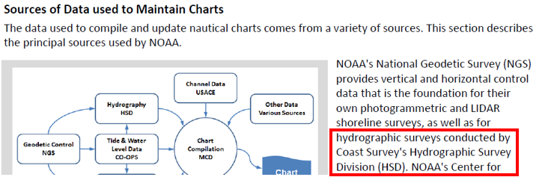

New Editions of Paper Charts

- Suggest that the “algorithm for determining when to issue a new edition of a raster chart” be explained or at least the logic outlined. This is important and the public should better understand the process.

- Suggest including a short list of examples of routine chart updates other than “ordinary hydrographic or shoreline surveys”.

- An issue not mentioned in the document is the timely transmission of the
Local Districts to UKHO for compiling the AIO cells. This creates extra work for the ECDIS Operators.

We do understand there is a huge amount of local information, but the ones concerning navigable channels, port approach and pier info (i.e. dredge ops, anything concerning buoyage etc.) should be transmitted to UKHO.

ENC and RNC Chart Updates and New Editions

Normalizing ENC Depth Contours

- Agree that standardizing scales and contour values is important.

- Concur with “adding additional integer unit contours”. (Pg. 18). They should change to overall metric format as soon as possible so that standard international convention for soundings and contours can be adopted, thereby eliminating the need for non-standard decimal metric values.

- New integer unit contours should not be added without removing decimal meter contours.

- Example of importance of metric values for contour lines in Port of Los Angeles. Los Angeles:
  - Original soundings were in fathoms, converted to meters to meet the ENC requirements.
  - Contours available are 9.1 m (5 Fathom) and 18.2 m (10 Fathom).
  - Cruise ships going to San Pedro usually select a safety contour of about 10 -
13 m to mark the safe navigable area.

An example of how this affects mariners is given below.

A safety contour of 11 m was selected by the vessel master. The ECDIS highlighted the nearest available contour of 18.2 m, which showed a light blue shade (not safe) on the area that ships are normally crossing and where the charted depth is actually more than 16 m (well above the 11m considered safe by the operator).

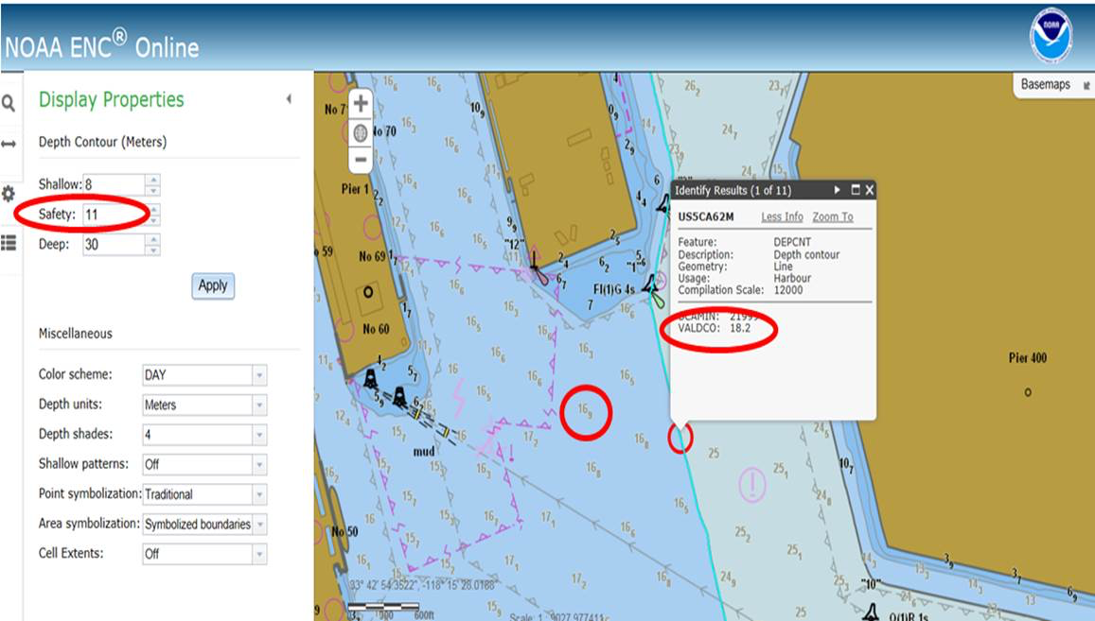

Metrification of ENC and Raster Charts

- Concur that US charts should be changed to overall metric format as soon as possible so that standard international convention for soundings and contours can be adopted.

- Document states that Coast Survey will change to metric “soon”. The document should define what “soon” is. Pick a reasonable fixed date (e.g. July 2020).

- Set a priority of charts to be converted to metric:

  - Sailing and Landfall charts (these are already proposed to be ENC-only)
  - Harbour and Approach charts of major ports (New York, LA / Long Beach, SW Pass / New Orleans, Houston / Galveston, San Francisco, Seattle, Miami, Chesapeake Bay entrance, in roughly that order)
  - Harbour and Approach charts of second-tier ports (e.g. Tampa, Boston, Portland)
  - Coastal

- Significant educational outreach will be needed on the move to metric for recreational boaters and other non-professional mariners.

Reducing Unwarranted Alarms/Isolated Dangers

- A problem not mentioned in the document is dual compilation scales within
one ENC due to an insert. For example: US chart 18757 (Avalon Bay) has an inset compiled at 1:10000, but because the ENC US5CA76M was compiled at 1:40000, the ECDIS "reads" the latest value. This creates overscale situations and jail bar alarms on the ECDIS, which in turn causes confusion and vessel masters reverting to the paper chart. We suggest creating a dedicated ENC for each inset to the chart.

- Add metric values to Non-dangerous point features of unknown depth (if the imperial-unit depths of these features are being updated, add metric values at the same time)

- When compiling metric values for subsea features on charts, do not forget to compile metric values for overhead clearance!

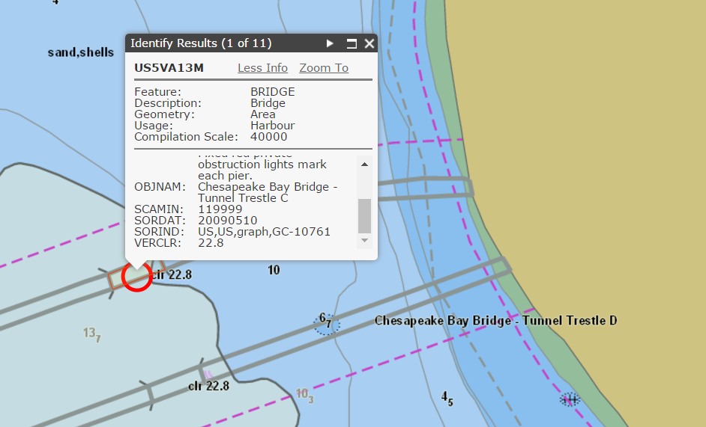

Channel Tabulations
- At least two USACE districts publish disclaimers stating that their channel condition surveys should not be used for navigation and that mariners should refer to NOS nautical charts. This conflicts with the National Charting Plan recommendation to refer mariners and pilots to current USACE surveys: if the USACE states that its surveys are not adequate for navigation, why should mariners and pilots rely upon them?

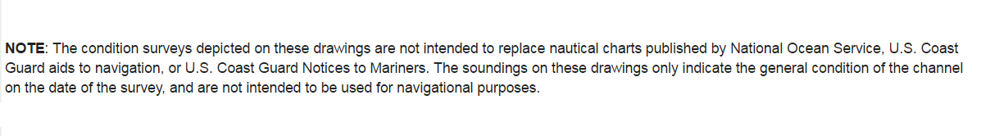
USACE Charleston District Disclaimer
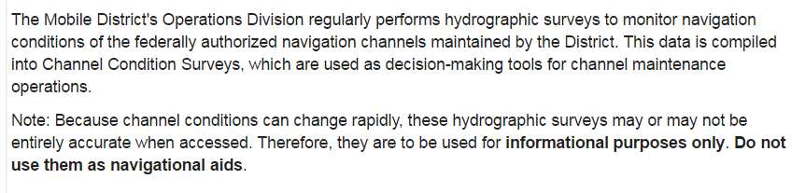
USACE Mobile District Disclaimer
- Document says that NOAA may remove all depths from channels (pg. 20). Do not agree – all channels should have depths!!!

Reported, Existence Doubtful, and Position Approximate Dangers
- This section should be its own separate 3rd-level heading. It is not a sub-section of USACE Channel Tabulations.

- To be consistent with MSC.232(82) par. 5.8.1 "if the mariner does not specify a
safety contour, this should default to 30m" we suggest to increase the proposed
depth value to 100 feet (30 m) as 30 meters has been recognized to be a safe
depth.

- Use Trusted sources (USACE, USCG, USN and contractors) to prove objects near their working areas (e.g. USACE proves/disproves object near USACE controlled channel)

- Use satellite and aerial photogrammetry to prove the existence/position of objects.
Example 1: Chart 11447, Key West Harbor RNC overlaid on Google Earth image.

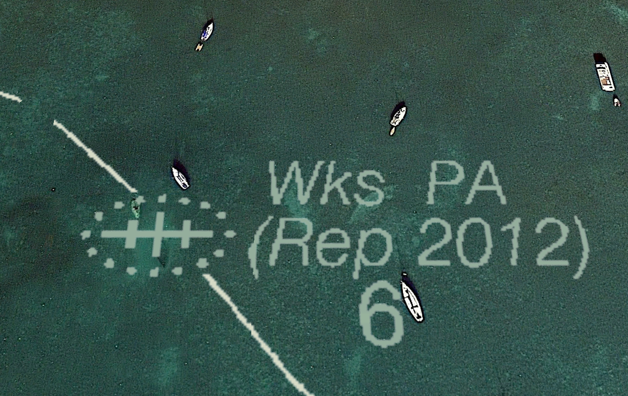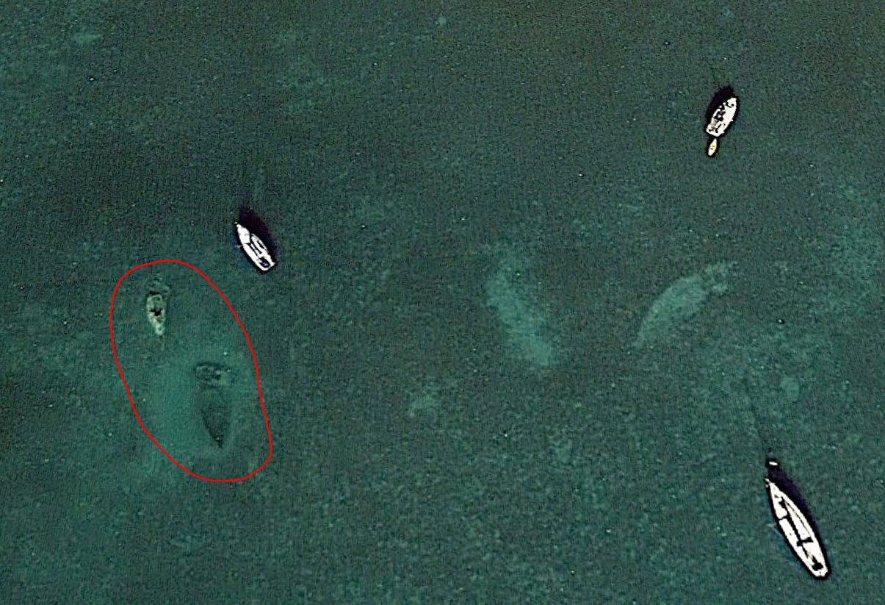

With RNC Overlay Without RNC Overlay

Example 2: Chart 11447, Key West Harbor RNC overlaid on Google Earth Image:
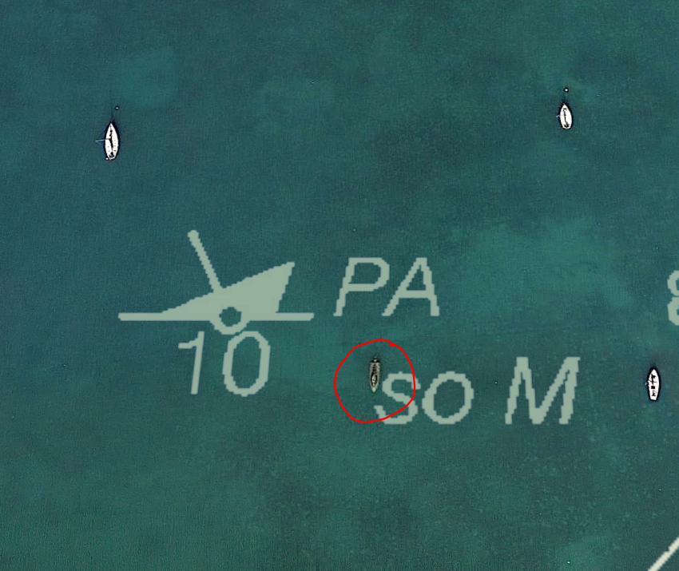
Anchored surface vessels are all facing bow into the wind (northerly) and are white. The sunken wreck is bow facing south and is green.

This is a low-cost, low-overhead method of detecting wrecks and obstructions in clear water. It won’t suffice for disprovals, but it will help de-clutter the chart.

Small Craft Charts
- Do the red arrows in Figure 19 on page 25 indicate “North” for each chart panel? It is not clear. Orientation of each chart panel does not necessarily mean the chart panel orientation is north up.

- Why not make small craft charts available in KMZ format? Google Earth has apps for Android and iPhone, and that would be a fast and easy way to get charts into a georeferenced format that people are already accustomed to using.

- Suggest making an “S” series of charts: Make small-scale small craft ENCs and RNCs as insets or overlays to a distinct set of larger-scale charts, much in the same manner that BOEM lease blocks in the Gulf of Mexico are overlaid on “A” series charts. This would put the charts together in a reasonable, logical manner without cluttering up existing charts or distracting commercial vessel masters.

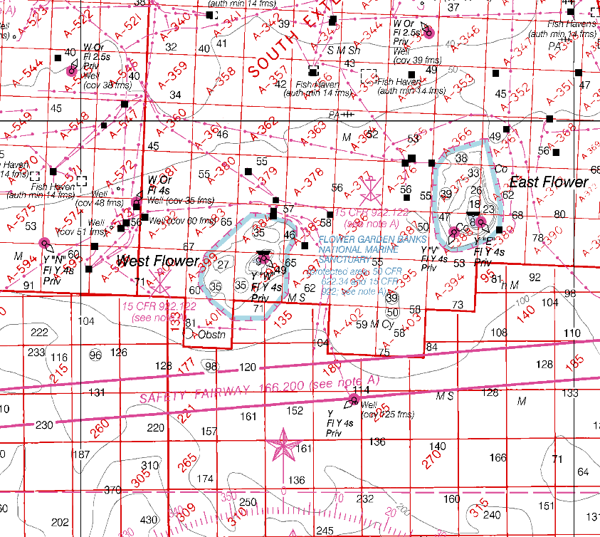

Chart 1116A: Mississippi River to Galveston w/ BOEM Lease Blocks

A similar “M” series of charts is recommended for the Lower Mississippi River, to prevent confusion and distraction:

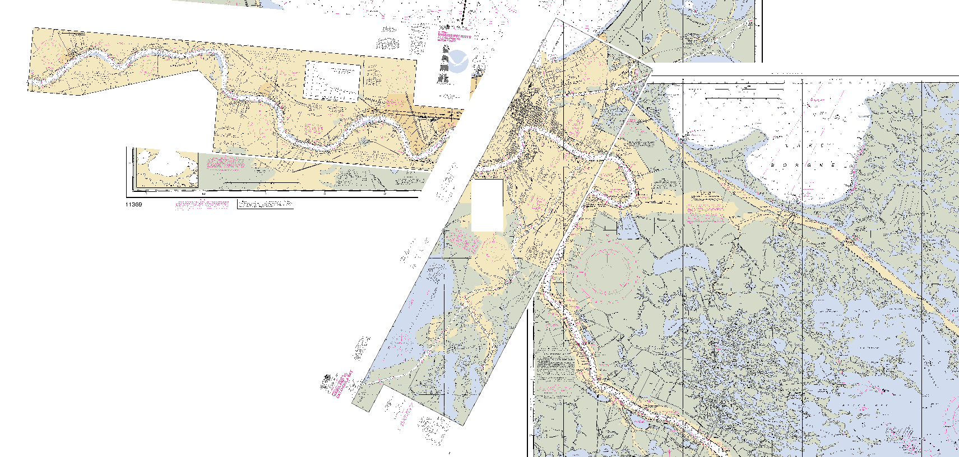

US Army Corps of Engineers Data for Ship Channels

- Discussion of USACE issues (pp. 19-20 and 26). Good that the issues are discussed openly in this National Charting Plan. There is no reason that the two major government bodies tasked with hydrographic surveys should not consult with one another for improvement and for standardisation of display and products.

All USACE districts whose products overlap NOS charts should be part of this National Charting Plan development, and they should be committing to timeframes for adoption of E-Hydro delivery methods/schedules and to adopting standard deliverables of both finished survey sheets and survey data to NOAA for review and compilation.

- Probable massive budget reductions to both organizations means that cooperation and resource sharing on hydrographic and charting projects is critical. Suggest setting up dedicated points of contact, specific communication protocols between MCD, AHB/PHB, and USACE districts to make this process easier.

- NOAA and USACE should set up site visits and/or virtual tours of NOAA MCD, AHB and PHB, and HSD offices to educate USACE personnel on NOAA requirements, including horizontal and vertical datums, sounding quality, position quality, object detection requirements, and chart compilation standards. This is a complex task and multiple sessions may be necessary.

- All USACE Districts must adopt and adhere to consistent quality standards between districts and within individual districts for the delivery of their products to NOAA, so that NOAA have confidence in the use of USACE data for NOS charts.

At this time, different USACE districts generate different products, and the products may not use internally consistent reference frames. An example is vertical datums in USACE survey charts in the Lower Mississippi River, USACE New Orleans District:

  - Southwest Pass = NOS MLLW (based on NAVD88)
  - South Pass = Mean Low Gulf (3’ separation from MLLW at Southwest Pass)
  - Mississippi River Deepwater Crossings Between New Orleans and Baton Rouge: Low Water Reference Plane 2007 for charts presented on .PDF or NGVD29 for XYZ files downloaded directly
  - Baton Rouge Harbor vertical datum: Mean Low Gulf

As a result of the above, overlapping NOAA and USACE charts may be in different datums, and data downloaded directly from the USACE may not be compatible with NOS data (e.g. soundings in feet below NGVD29). Serious focus will be required to ensure that USACE and NOAA data are compatible and of adequate quality for nautical charting.

- Given that USACE controlled-depth channels are some of THE most navigationally significant waterways in the nation, suggest working with USACE to ensure that “better-than-CATZOC B” coverage is obtained during all routine channel condition surveys. This may be as simple as collecting side scan sonar data and sending to a designated NOAA unit, USACE central office, or Contractor for object detection analysis.

If a contractor hired by the USACE for channel condition surveys is also a trusted NOAA contractor, then the USACE may specify object detection surveying as part of the scope of channel condition surveys, and that the contractor shall process object detection data in accordance with NOS Specifications and submit the object detection data to AHB or PHB for review. This will save effort on the part of all organizations and is more cost-effective for the government.

- For distributing NOAA, USCG aids to navigation, and USACE controlled channel updates simultaneously, suggest linking the distribution website to Notice to Mariners, which is where people already go look for updates

- It is important to recognize that USACE E-Hydro is an ESRI-based distribution format, NOT a set of survey specifications and deliverables. Incorporating USACE E-Hydro deliverables must be considered as a separate item, and E-Hydro will not replace serious discussions on survey quality and survey specifications.

- USACE has declared that only data from e-Hydro should be used. Good step – easier for NOAA, but how will this affect getting data from districts that do not use e-Hydro onto charts?

- Need to determine a fixed timeline for E-Hydro rollout.

Vision for the Future of the Nautical Charting

The time horizon of this vision is unclear.

The End of Raster Nautical Charts (Sunset of Paper Charts)
The recreational boating community has had a strong reaction to the concept of sunseting paper charts. While more and more boaters are accessing chart products online and via digital means, there is still a large user base of the traditional paper chart products. Echoing the HSRP’s comments in the Recreational Boating issue paper finalized at the Seattle meeting. Data for recreational boaters must continue to be available in a variety of formats, including paper charts.

Port ECDIS – Port ENC
The future of nautical charts should reflect the discussions of Port ECDIS – Port ENC which comply with the latest international standards for metrification and bathymetry density at least every meter starting from 30 meters inland. Additionally this product should have a real time weather data overlay. These elements are the foundation to precision navigation in ports and channels.

Open Data and Marine Spatial Data Infrastructure

- Is the MSDI a bathymetric database for all data submitted to NOAA, all data from NOAA sources only, or only OCS? Would suggest a wider field than just OCS data. Database is critical for Marine Spatial Data Infrastructure.

