NOAA HSRP press and articles 2007-2023 updated 7Nov2023

NOAA Hydrographic Services Review Panel (HSRP) Federal Advisory Committee in the News
This list contains articles, video and media coverage mentioning the NOAA HSRP Federal Advisory Committee managed by Office of Coast Survey, National Ocean Service, NOAA. The most updated version is online: https://www.nauticalcharts.noaa.gov/hsrp/press.html

2023

“Federal agencies addressing the geodesy crisis.” GPS World, David Zilkoski, Nov 1, 2023.
https://www.gpsworld.com/federal-agencies-addressing-the-geodesy-crisis/

Dr. Legna Torres-Garcia was an invited panelist at the NOAA Hydrographic Services Review Panel in Puerto Rico - Legna presented on the probabilities of hurricane-induced coastal erosion in Puerto Rico as part of a panel about coastal resilience planning in the U.S. Caribbean. St. Petersburg Coastal and Marine Science Center, Mar 17, 2023.
https://www.usgs.gov/centers/spcmsc/news/dr-legna-torres-garcia-was-invited-panelist-noaa-hydrographic-services-review

“USACE participates in NOAA hydrographic review panel”. Jennifer Garcia, JACKSONVILLE DISTRICT, ANTILLES OFFICE, March 1, 2023.
https://www.saj.usace.army.mil/Media/News-Stories/Article/3315350/usace-participates-in-noaa-hydrographic-review-panel/

X : Post conversation Jenniffer González @RepJenniffer, 11:24am, Mar 2, 2023, 1503 views
@NOAA's Hydrographic Services Review Panel is holding its spring public meeting this year in #PuertoRico! The panel plays a critical role advising NOAA on its navigation-related services & data products. I'm pleased to join them as Co-Chair of the House Ocean Caucus.
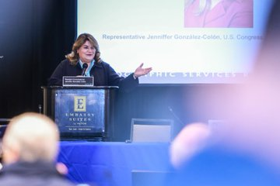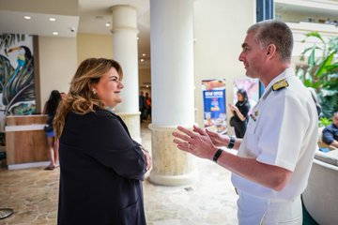
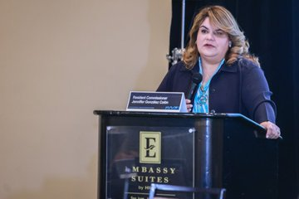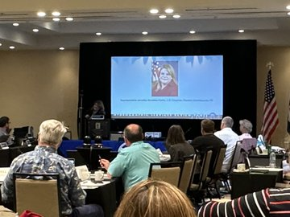

2022

“NOAA.” Maritime, date. website https://www.

2021

“COMIT’s Director, Murawski, to present at March NOAA OCS Hydrographic Services Review Panel Meeting” Sarah Grasty, February 26, 2021.
https://www.marine.usf.edu/comit/2021/02/26/959/

“A COMMITMENT TO ENGAGE AND INVOLVE STAKEHOLDERS: THE EXPERIENCE OF THE UNITED STATES OF AMERICA’S HYDROGRAPHIC SERVICES REVIEW PANEL FEDERAL ADVISORY COMMITTEE” International Hydrographic Review, Volume 29, November 30, 2021 and January 7, 2022.
https://ihr.iho.int/articles/a-commitment-to-engage-and-involve-stakeholders-the-experience-of-the-united-states-of-americas-hydrographic-services-review-panel-federal-advisory-committee/

2020

“NOAA Seeks Feedback on Ocean and Coastal Mapping Strategies.” Maritime Executive, September 11, 2020. https://www.maritime-executive.com/corporate/noaa-seeks-feedback-on-ocean-and-coastal-mapping-strategies

“NOAA hosts virtual meeting to discuss offshore mapping progress in Alaska.” SeafoodSource.com, Ben Fisher, May 19, 2020, by
https://www.seafoodsource.com/news/supply-trade/noaa-hosts-virtual-meeting-to-discuss-offshore-mapping-progress-in-alaska

“HSRP suggests bright future for bathymetric/topographic lidar.” Lidar Magazine, May 8, 2020
https://lidarmag.com/2020/05/08/hsrp-suggests-bright-future-for-bathymetric-topographic-lidar/

2019

"Small bump in PORTS® funding for FY20." The Beacon, Maritime Exchange for the Delaware River and Bay, Fall 2019, Volume 29, No. 4, pages 1, 8;
https://www.maritimedelriv.com/Publications/Beacon/issues/Fall2019/index.html#page=1

“New GCOOS-Funded Radar Installations at the Mouth of the Mississippi Will Help to Protect Lives and Support the Nation’s Blue Economy.” NewsWise, 30-Aug-2019, Gulf of Mexico Coastal Ocean Observing System-Regional Association (GCOOS-RA)
https://www.newswise.com/articles/new-gcoos-funded-radar-installations-at-the-mouth-of-the-mississippi-will-help-to-protect-lives-and-support-the-nation-s-blue-economy

“Woolpert’s Qassim Abdullah Selected for NOAA’s Hydrographic Services Review Panel.” October 4, 2019.
https://woolpert.com/news/press-releases/woolperts-qassim-abdullah-selected-for-noaas-hydrographic-services-review-panel/

August and September 2018: Juneau AK HSRP meeting - HSRP news and tv articles:

“Dewberry’s Dave Maune, Ph.D., Reappointed to NOAA Hydrographic Services Review Panel, Geospatial expert selected to serve another four-year term”. The American Surveyor, Oct 5, 2018.
https://amerisurv.com/2018/10/05/dewberrys-dave-maune-ph-d-reappointed-to-noaa-hydrographic-services-review-panel/

“Outdated navigational charts are an Arctic maritime disaster in the making.” Arctic Today, September 10, 2018, Columnist Dermot Cole
https://www.arctictoday.com/outdated-navigational-charts-arctic-maritime-disaster-making/

“AK Senators support NOAA to survey Arctic Ocean.” Web Center 11 Fairbanks (KTVF),
Published: Aug. 29, 2018, 12:39 AM EDT, Sara Tewksbury video is 1:21 minute:
https://www.webcenter11.com/content/news/AK-Senators-support-NOAA-to-survey-Arctic-Ocean-491956021.html

"As sea levels rise, more data needed, experts say 31 communities at risk from flooding and erosion, but water levels in much of coastal Alaska aren’t monitored"
Juneau Empire, August 28, 2018 06:22pm.
https://www.juneauempire.com/news/as-sea-levels-rise-more-data-needed-experts-say/

"NOAA to work on Arctic at Juneau panel." Juneau Empire, August 25, 2018.
https://www.juneauempire.com/news/noaa-to-work-on-arctic-at-juneau-panel/

"Ocean minds tackle Arctic marine traffic bump." Juneau Empire, August 30, 2018.
https://www.juneauempire.com/news/ocean-minds-tackle-arctic-marine-traffic-bump/

2017

”NOAA Seeks New Members for Hydrographic Advisory Panel.” Maritime Executive, March 27, 2017.
https://www.maritime-executive.com/corporate/noaa-seeks-new-members-for-hydrographic-advisory-panel

2013

“MAPPS President Testifies on Hydrographic Services Bill.” GeoDataPoint, by Point of Beginning (POB), June 13, 2013.
https://www.pobonline.com/articles/99301-mapps-president-testifies-on-hydrographic-services-bill

2012

“NOAA to Hold Public Meeting in Anchorage, Alaska“. Marine Link, May 7, 2012.
https://www.marinelink.com/news/anchorage-meeting-public344446

“New Alaska Navigational Chart Makes Increased Arctic Shipping Safer.” The Maritime Executive, May 23, 2012.
https://www.maritime-executive.com/article/new-alaska-navigational-chart-makes-increased-arctic-shipping-safer

“NOAA Panel to Discuss Gulf of Mexico Maritime Issues in New Orleans”. Cruise Industry News, November 20, 2012.
https://cruiseindustrynews.com/cruise-news/2012/11/noaa-panel-to-discuss-gulf-of-mexico-maritime-issues-in-new-orleans/

2011

“Hydrographic Services Review Panel Meeting, Oct 26-27, 2011”. Maritime Logistics Professional, October 5, 2011.
https://www.maritimeprofessional.com/news/hydrographic-services-review-panel-meeting-220721

2007

“NOAA’s Hydrographic Services Review Panel.” Hydro International, March 10, 2007.
https://www.hydro-international.com/content/article/noaa-s-hydrographic-services-review-panel

